Lab 6: Light Intensity
We all know that when a light is farther away it doesn’t look as bright. In this lab we’ll be figuring out the rules that describe just how much it appears dimmer. For example, if you move a star twice as far away from you, does it look half as bright?
In this lab we’ll be doing some graphing, so you’ll need the appropriate supplies for that – either a printout of the graph space or the ability to open it up in your favorite paint program.
Once we figure out just how much brightness falls with distance, we’ll be doing some calculations to test out what we’ve just learned, so you’ll also want a calculator.
This lab has a total of 45 points, and is due by the end of Friday October 8.

Part 1: Exponents Review (6 points)
Similar to how multiplication is adding a number to itself a certain number of times (for example, 3×4 is 3+3+3+3), there’s a type of calculation in which you multiply a number by itself a certain number of times. In this case the number of multiplications is given as a little number in the upper right, called an exponent. For example, 3⁴ is equal to 3×3×3×3 = 81. When reading that out loud, you’d say “3 raised to the power of 4,” or perhaps “3 raised to the 4th power.” (Naturally this gets shortened to things like “3 to the 4th.”)
Before we go much further, let’s get some practice. Some of the calculations below can be done in your head, while others will call for a calculator. If you have a calculator that does more than simple arithmetic, you can try looking for a key that looks like x^{y} or a ^. If you don’t have a calculator like that, Google’s built-in calculator understands 3^4 as 3⁴.
Evaluate the following: [3 points total]
2⁵ =
5² =
4.5⁶ =
Exponents are commonly seen in geometry. For example, the area of a square with a side of length s is s², and the volume of a cube with side s is s³. Because of those, the power of 2 and the power of 3 are often referred to as the square and the cube of a number. 5² can be read as “5 squared,” and 8³ can be read as “8 cubed.”
If the exponent is a fraction – 1 over something – then it undoes the “to the something power.” For example, 3⁴ is 81, and 81^{1/4} is 3. Raising something to the power of 1/2 (or 0.5) is the same as taking the square root, and raising something to the 1/3 power is the same as taking the cube root.
Be careful when feeding fractional exponents into a calculator: it’ll interpret 81^1/4 as “raise 81 to the power of 1, and then divide the result by 4,” instead of “raise 81 to the 1/4 power.” To make sure it doesn’t misunderstand you, you can try putting the fraction in parentheses – 81^(1/4) – or you can write it as a decimal: 81^0.25.
Evaluate the following: [3 points total]
9^{1/2} =
10^{1/2} =
200^{1/3} =

As mentioned earlier, exponents often pop up in geometry: for example, the area of a circle is π×r², where r is the radius of the circle and π is a number equal to about 3.14. As another example, the volume of a sphere is (4/3)×π×r³.
Exponents also appear often in physics. The energy of a moving object is proportional to its speed squared, and the amount of light given off by a hot object is proportional to its temperature raised to the fourth power.
There are even cases where exponents work in opposite directions from what you’re trying to figure out. For example, the formula for gravity involves a fraction with distance squared on the bottom. If you have a pair of objects and change their separation to three times what it used to be, the gravitational force between them dwindles to 1/9 as strong. The strength of tides involves a fraction with distance cubed on the bottom.
In this lab, we’re going to look at something similar: how things seem to get less bright as you get farther away from them – like how a nearby birthday candle can appear brighter to your eye than a distant bonfire.

Part 2: Light, at a Distance (18 points)
Before we jump straight to the graph, it’ll be better to write out our observations first. Below is a table with enough space for 10 observations (or more if you edit the table to add more rows). We’ll fill in the first two columns using measurements of the light source’s distance from the detector, and what the meter says about the light it’s getting. Leave the third column blank for now.
Distance (in.) | Intensity | Normalized Intensity
(10 points for the whole table)
If the light meter tells us “500” that doesn’t say a whole lot about the light source – it could be a high-powered light that is far away from the detector, or something dimmer and closer.
If the formula for how bright something looks involves the distance to the light source, it’ll also depend on how much light that source is giving off. We’re not interested in that second thing; all we care about here is how the brightness drops as the light source moves farther away. (For example, as far as we care, the brightness dropping from “400” to “200” is the same as it dropping from “300” to “150” – either way, the detector is only getting half as much light after the move.)
So let’s take out any aspects that depend on the brightness of the light bulb. We can do this by picking a reference setup and declaring that to be “1” in terms of normalized brightness. As the light moves farther away, the brightness will decrease, and we’ll be able to see just how much by looking at the fraction of that “1.”
For the graph space on the next page, I set up the models so that they treat the brightness at a distance of 7 inches as the reference. So for the third column in the table above, you should divide each brightness reading by the 7-inch reading.
Once you’ve done that, go ahead and place the data points onto the graph on the next page. The x-coordinates will be the distances in inches, and the y-coordinates will be the normalized brightness readings.
You can choose whichever method of creating the graph is most convenient for you – such as drawing the dots onto a printed page, or opening up the graph image in a paint program and adding them there – but you will need to find a way to “turn in” your graph. Once you’ve gotten it into an electronic format (perhaps by taking a photo of it), you can try pasting it into this document, or sending it to me as a separate file. If you get stuck, let me know and we can figure out what to do.
Your graph is worth 5 points.

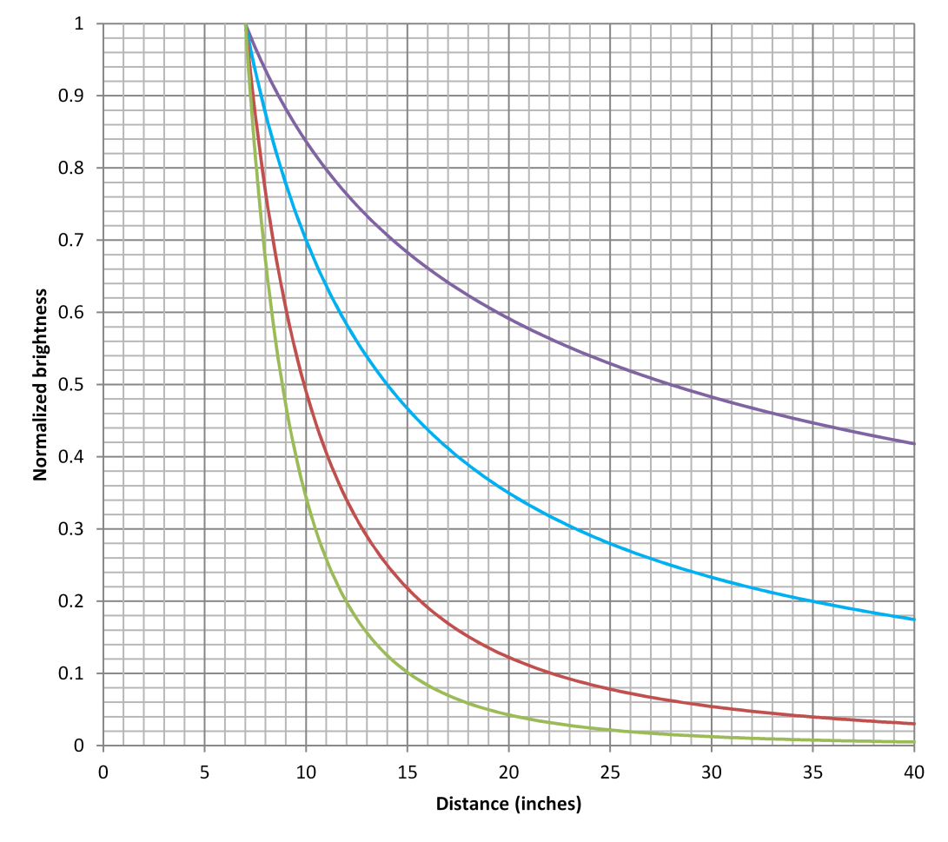
Aside from the data points you’ve added, this graph has four curves – each representing a different possible description of how quickly a light source gets fainter as it moves farther away. All four are relative to the brightness at 7 inches.
The highest curve (in purple) is what the data would look like if the brightness dimmed proportionally to the square root of the distance. (Move the light four times farther away, and it appears 1/2 as bright.)
The second curve (light blue) is what the data would look like if the brightness dimmed proportionally to the distance. (Move the light four times farther away, and it appears 1/4 as bright.)
The third curve (red) is what the data would look like if the brightness dimmed proportionally to the distance squared. (Move the light four times farther away, and it appears 1/16 as bright.)
The lowest curve (light green) is what the data would look like if the brightness dimmed proportionally to the distance cubed. (Move the light four times farther away, and it appears 1/64 as bright.)

Which of the provided relationships best matches our data? [1 point]

Most likely, the observations don’t perfectly line up with the best-match relationship. There might have been some imperfections in our setup, or in how the observations were conducted. Part of the scientific process is figuring out the imperfections in our methods and either fixing them next time, or (if they can’t be fixed) at least accounting for them. Using complete sentences, describe two possibilities that could explain why the data aren’t a perfect match for the ideal model. [2 points]

Part 3: Trying It Out (15 points)
Hooray! We’ve found out how much a light source seems to dim as you get further away from it.
If we’re comparing a setup with the known intensity for a given light source at a reference distance, then the relationship looks like this:
$$I_{1}×{d_{1}}^{(?)}= I_{2}×{d_{2}}^{(?)}$$
…where I₂ and d₂ are the intensity and distance you’re looking at, I₁ and d₁ are the reference intensity and distance, and the (?) is the power we figured out from the graphing. (For example, if the intensity goes down like the distance to the third power, then the d’s would be raised to the third power.)
If we’re interested in the light intensity relative to the reference value – for example, if we’re interested in the Sun’s brightness at other planets compared to how it looks from Earth – then we can rearrange things like this:
$$\frac{I_{2}}{I_{1}}= {\left(\frac{d_{1}}{d_{2}}\right)}^{(?)}$$
So if we’re interested in the Sun’s brightness from Neptune’s distance compared to at Earth’s distance, then the answer we’re looking for is I_{Neptune}/I_{Earth}, and it is equal to (d_{Earth}/d_{Neptune})^{(?)}. Neptune is about 30 AU away from the Sun, and Earth is 1 AU away from the Sun, so the answer would be (1/30) raised to the (?) power. Calculating that lets us say, “From Neptune, the Sun appears ____ times as bright as seen from Earth.”
Go ahead and calculate that out – how bright is the Sun, as seen from Neptune (compared to what Earth sees)? Give your answer in a complete sentence. [1 point]

Let’s try it for a few other places.
Compared to how bright the Sun is as seen from Earth, how bright is the Sun as seen from Mars? (Mars is 1.52 AU from the Sun.) [1 point]

Compared to how bright the Sun is as seen from Earth, how bright is the Sun as seen from Mercury? (Mercury is 0.39 AU from the Sun.) [1 point]

Compared to how bright the Sun is as seen from Earth, how bright is it at Pluto? (Pluto is 39.5 AU from the Sun on average.) [1 point]

Quick “sanity check”: If a planet is closer to the Sun, the Sun should appear brighter there, and if a planet is farther away, the Sun should appear fainter. Do your answers above agree with that?

…and of course, this works with other light sources too.
Let’s say you’re camping in the wilderness with a group of friends. You’re enjoying a campfire, but you feel it’s a little too bright – you want your eyes to dark-adjust a little more to see the stars better.
You’re currently seated 10 feet away from the campfire. If you move back to a distance of 25 feet, how bright will the campfire look compared to before? [1 point]

In the above calculations, we looked at a desired distance, and calculated the expected brightness of the Sun (or other bright object). We can arrange the relationship a different way, and find the distance at which you’ll experience a desired brightness:
$$\frac{d_{2}}{d_{1}}={\left(\frac{I_{1}}{I_{2}}\right)}^{1/(?)}$$
Here the answer we’re looking for is d₂/d₁, the new distance compared to the original distance. If we’re comparing to Earth, then that could be thought of as a distance in AU. If it’s something else, like your distance from a campfire, it’ll still be compared to that original distance – for example, “2.3 times as far away” rather than a particular number of feet. (If you do want an answer in feet, simply multiply by your original distance in feet.)
That answer is equal to the original intensity divided by the desired intensity, raised to the power of 1/(?).
Let’s say you’re curious about where in the Solar System the Sun would look 75% as bright as at Earth. That fraction becomes (1/0.75), and it gets raised to the power of 1/(?).
Go ahead and calculate that out. How far do you have to be from the Sun, in order for it to look 0.75 times as bright as what Earth sees? [1 point]

How far should you be from the Sun for it to look 10% as bright as what Earth sees? [1 point]

What if you want the Sun to look a sizzling 100 times as bright as what Earth sees? [1 point]

If you’re interested in checking your above answers, make sure that if the Sun looks fainter, you’re farther away. Not just in terms of being closer or farther away than 1 AU – you can also compare it to your previous answers. For example, does the Sun look brighter or fainter than “0.75 times what Earth sees” at Mars? How does your answer compare to Mars’s distance?
Let’s venture outside of the Solar System. As astronomers discover planets orbiting around other stars, an important concept to consider is each star’s habitable zone – the region around the star where you’d expect a planet to have Earth-like temperatures, in particular temperatures that would allow liquid water. If a planet is too close to its star, any water would turn to vapor. Too far away, and the planet gets so little energy that any water would freeze. The Sun’s habitable zone is centered around a distance of 1 AU.
Let’s think about the habitable zones for other stars.
The star Vega gives off 40 times as much total light as the Sun. Would Vega’s habitable zone be closer in than 1 AU, or farther away than 1 AU? (You shouldn’t need a calculator yet.) [1 point]
Let’s figure out where Vega’s habitable zone would be. We’ll imagine starting at 1 AU, and traveling to a distance where the star is 1/40 as bright as we’d see at 1 AU. In other words, d₁ = 1 AU, and (I₂/I₁) is 1/40. Use those values (perhaps flipping a fraction) in the above formula to figure out the distance from Vega at which a planet would get Earth-like amounts of light. [1 point]

You might remember the monstrous star Deneb from the nighttime observing and from the Scale Models lab. Deneb gives off about 200,000 times as much energy as the Sun. How far away from Deneb would its habitable zone be? [1 point]

The closest star to the Solar System, Proxima Centauri, is a small dim star that gives off only 0.0017 times as much light as the Sun. How close would a planet have to be to Proxima Centauri to get the same amount of energy that Earth does from the Sun? [1 point]

Astronomers have discovered two planets around Proxima Centauri (though there may be others that haven’t been discovered yet). The planet Proxima Centauri b (discovered in 2013) is located about 0.0486 AU away from its sun, and the planet Proxima Centauri c (discovered in 2019) is about 1.49 AU away from its sun. Based on the amount of light they get, would you expect these planets to be warmer than Earth or cooler than Earth? Explain your answer. [3 points]

Part 4: Wrap-Up Questions (6 points)
If we see three stars in the night sky that look to be the same brightness, does that mean they are all about the same distance away from us? Why or why not? [2 points]

A table showing the distances of the planets from the Sun is below. If you had the ability to move any planet 0.1 AU closer to the Sun – for example, moving Venus to 0.62 AU or moving Jupiter to 5.1 AU – which planet would see the largest change in the amount of sunlight it gets? Explain your answer. [2 points]

Planet | Mercury | Venus | Earth | Mars | Jupiter | Saturn | Uranus | Neptune
Dist. (AU) | 0.39 | 0.72 | 1.00 | 1.52 | 5.2 | 9.6 | 19.2 | 30.1

Your friend is figuring out where to put some solar panels for a building: either on the roof of the building itself, or on the roof of a nearby covered parking lot. Putting the panels on top of the building will be more expensive, but your friend says they’ll collect more energy because they’ll be about 60 feet closer to the Sun. Would it be better to put the panels on top of the building? Explain your answer. (Ignore other issues like shadows.) [2 points]

